Grant Application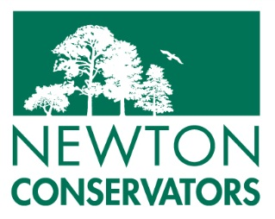 (v.3.18.24)

Instructions
Please complete this form on your computer and save it as a PDF or DOC file. Include your name or the project name as part of the file name. Email the file to application@newtonconservators.org.
Before applying, please carefully review the program criteria. If you have any questions, please send them to grantquestions@newtonconservators.org. Proposals will be reviewed during the board meeting in the month following submission, and applicants will generally be notified 4-6 weeks after proposals are submitted.
Application Deadlines: Fall: October 31 Winter: January 31 Spring: May 31

Project Information
Project Title
Organization or School Name
Total Funds Requested
Today’s Date (mm/dd/yyyy)

Contact Information
Proposal Submitted By
Mailing Address
City ST ZIP
Cell or Home Phone
Work Phone
E-Mail Address
Project Lead (if different)
Names of Other Project Leaders
Make Award Check Payable to

Brief Project Abstract
Please summarize the project (maximum 250 words)

Who Benefits from the project?
Please describe the number of people and demographics served. Include the number of students and their grade levels, if applicable.

How will the proposed project meet the grant program criteria?
Please describe the project objectives and how they relate to the grant program criteria.

Project Timeline
Include start and end dates and key milestones.

Communications
How will the results of the project be communicated to the public?

Other Funding
Is the project dependent on additional funding from other sources? If so, describe status of other funding and the roles of other organization(s) you are collaborating with. Can the project be completed if additional funding is not received?
Will future funding be requested from Newton Conservators?

Does your project require landowner permission or regulatory approvals?
If so, please describe the status of your request for this permission

Itemized Budget
Please provide justification, as needed.

Full Project Description
(1) What are the goals and objectives? (2) How will they be met (activities and methods)? (3) What are your measures of success (evaluation)? (Maximum 1000 words).

Describe your plan for long-term follow-up or maintenance, if applicable?
To be successful, some projects are likely to require follow-up after the grant period ends. Please describe how you plan to address this.

